UNIT III
COMPILER DESIGN

Intermediate Languages
Three ways of intermediate representation: * Syntax tree * Postfix notation * Three address code

INTERMEDIATE CODE GENERATION

INTRODUCTION

The front end translates a source program into an intermediate representation from which the back end generates target code.

Benefits of using a machine-independent intermediate form are:

1. Retargeting is facilitated. That is, a compiler for a different machine can be created by attaching a back end for the new machine to an existing front end.
2. A machine-independent code optimizer can be applied to the intermediate representation.
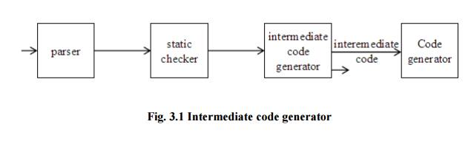
INTERMEDIATE LANGUAGES
Three ways of intermediate representation:
* Syntax tree
* Postfix notation
* Three address code

The semantic rules for generating three-address code from common programming language constructs are similar to those for constructing syntax trees or for generating postfix notation.

Graphical Representations: Syntax tree:

A syntax tree depicts the natural hierarchical structure of a source program. A dag (Directed Acyclic Graph) gives the same information but in a more compact way because common subexpressions are identified. A syntax tree and dag for the assignment statement a : = b * - c + b * - c are shown in Fig.3.2:

Postfix notation:

Postfix notation is a linearized representation of a syntax tree; it is a list of the nodes of the tree in which a node appears immediately after its children. The postfix notation for the syntax tree given above is

Syntax-directed definition:

Syntax trees for assignment statements are produced by the syntax-directed definition. Non-terminal S generates an assignment statement. The two binary operators + and * are examples of the full operator set in a typical language. Operator associativities and precedences are the usual ones, even though they have not been put into the grammar. This definition constructs the tree from the input a : = b * - c + b* - c.
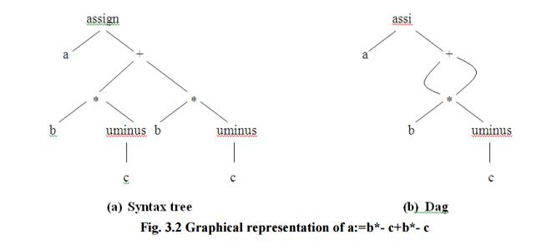
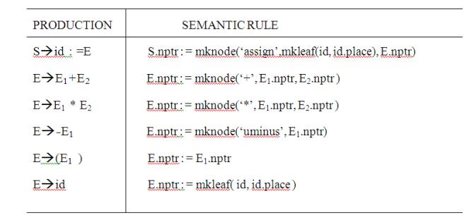
Fig. 3.3 Syntax-directed definition to produce syntax

The token id has an attribute place that points to the symbol-table entry for the toen identifier. A symbol-table entry can be found from an attribute id.name, representing the lexeme associated with that occurrence of id. If the lexical analyzer holds all lexemes in a single array of characters, then attribute name might be the index of the first character of the lexeme.
Two representations of the syntax tree are as follows. In (a) each node is represented as a record with a field for its operator and additional fields for pointers to its children. In (b), nodes
are allocated from an array of records and the index or position of the node serves as the pointer to the node. All the nodes in the syntax tree can be visited by following pointers, starting from the root at position 10.
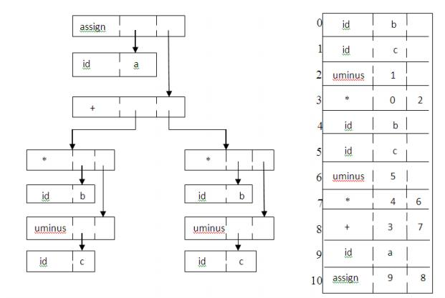
Fig. 3.4 Two representations of the syntax tree

Three-address code

Three-address code is a sequence of statements of the general form x : = y op z

where x, y and z are names, constants, or compiler-generated temporaries; op stands for any operator, such as a fixed- or floating-point arithmetic operator, or a logical operator on boolean-valued data. Thus a source language expression like x+ y*z might be translated into a sequence


where t1 and t2 are compiler-generated temporary names.
Advantages of three-address code:
* The unraveling of complicated arithmetic expressions and of statements makes three-address code desirable for target code generation and optimization. * The use of names for the intermediate values computed by a program allows three-address code to be easily rearranged - unlike postfix notation.
Three-address code is a linearized representation of a syntax tree or a dag in which explicit names correspond to the interior nodes of the graph. The syntax tree and dag are represented by the three-address code sequences. Variable names can appear directly in three address statements.

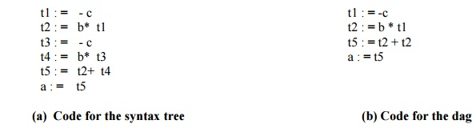
Fig.3.5 Three-address code corresponding to the syntax tree and dag

The reason for the term “three-address code” is that each statement usually contains three addresses, two for the operands and one for the result.

Types of Three-Address Statements:
The common three-address statements are:

1. Assignment statements of the form x : = y op z, where op is a binary arithmetic or logical operation.

2. Assignment instructions of the form x : = op y, where op is a unary operation. Essential unary operations include unary minus, logical negation, shift operators, and conversion operators that, for example, convert a fixed-point number to a floating-point number.

3. Copy statements of the form x : = y where the value of y is assigned to x.

4. The unconditional jump goto L. The three-address statement with label L is the next to be executed.

5. Conditional jumps such as if x relop y goto L. This instruction applies a relational operator (<, =, >=, etc. ) to x and y, and executes the statement with label L next if x stands in relation relop to y. If not, the three-address statement following if x relop y as in the usual sequence.

6. param x and call p, n for procedure calls and return y, where y representing a returned value is optional. For example,
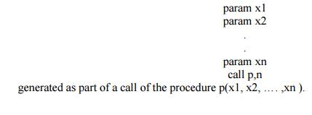
7.Indexed assignments of the form x : = y[i] and x[i] : = y.
8.Address and pointer assignments of the form x : = &y , x : = *y, and *x : = y.

Syntax-Directed Translation into Three-Address Code:

When three-address code is generated, temporary names are made up for the interior nodes of a syntax tree. For example, id : = E consists of code to evaluate E into some temporary t, followed by the assignment id.place : = t.

Given input a : = b * - c + b * - c, the three-address code is as shown in Fig. 8.3a. The synthesized attribute S.code represents the three-address code for the assignment S.

The nonterminal E has two attributes :
1. E.place, the name that will hold the value of E , and
2. E.code, the sequence of three-address statements evaluating E.

Syntax-directed definition to produce three-address code for assignments
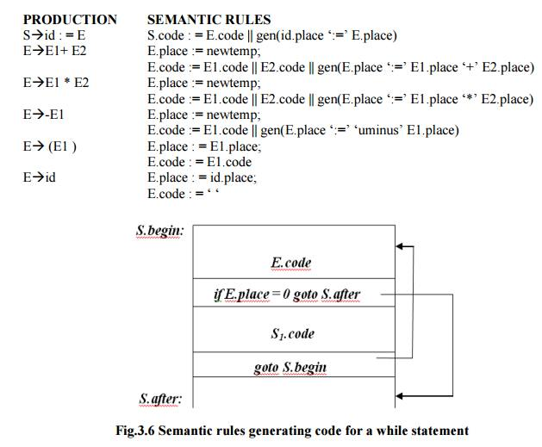
Fig.3.6 Semantic rules generating code for a while statement

PRODUCTION : SEMANTIC RULES
S->while E do S1: S.begin := newlabel;
S.after := newlabel;

S.code := gen(S.begin ‘:’) ||
E.code ||
gen ( ‘if’ E.place ‘=’ ‘0’ ‘goto’ S.after)|| S1.code ||
gen ( ‘goto’ S.begin) || gen ( S.after ‘:’)

The function newtemp returns a sequence of distinct names t1,t2,….. in response to successive calls.

Ø Notation gen(x ‘:=’ y ‘+’ z) is used to represent three-address statement x := y + z. Expressions appearing instead of variables like x, y and z are evaluated when passed to gen, and quoted operators or operand, like ‘+’ are taken literally.

Ø Flow-of-control statements can be added to the language of assignments. The code for S
while E do S1 is generated using new attributes S.begin and S.after to mark the first statement in the code for E and the statement following the code for S, respectively.

¬ The function newlabel returns a new label every time it is called.

We assume that a non-zero expression represents true; that is when the value of E becomes zero, control leaves the while statement.

Implementation of Three-Address Statements:

A three-address statement is an abstract form of intermediate code. In a compiler, these statements can be implemented as records with fields for the operator and the operands. Three such representations are: Quadruples, Triples, Indirect triples
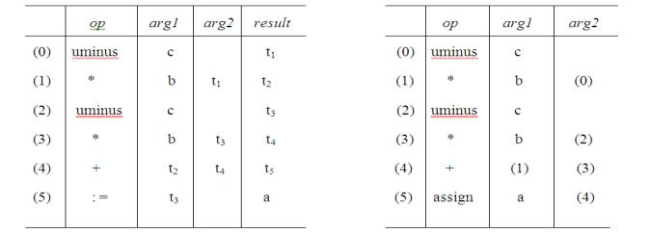
Fig.3.7 (a) Quadruples (b) Triples

Quadruples:
Ø A quadruple is a record structure with four fields, which are, op, arg1, arg2 and result.

Ø The op field contains an internal code for the operator. The three-address statement x : = y op z is represented by placing y in arg1, z in arg2 and x in result.
Ø The contents of fields arg1, arg2 and result are normally pointers to the symbol- entries for the names represented by these fields. If so, temporary names must be entered into the symbol table as they are created.

Triples:

Ø To avoid entering temporary names into the symbol table, we might refer to a temporary value by the position of the statement that computes it.

Ø If we do so, three-address statements can be represented by records with only three fields: op, arg1 and arg2.

Ø The fields arg1 and arg2, for the arguments of op, are either pointers to the symbol table or pointers into the triple structure ( for temporary values ).
Ø Since three fields are used, this intermediate code format is known as triples.

A ternary operation like x[i] : = y requires two entries in the triple structure while x : = y[i] is naturally represented as two operations.
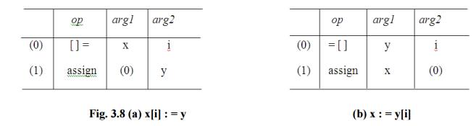
Indirect Triples:

Another implementation of three-address code is that of listing pointers to triples, rather than listing the triples themselves. This implementation is called indirect triples.

For example, let us use an array statement to list pointers to triples in the desired order. Then the triples shown above might be represented as follows:
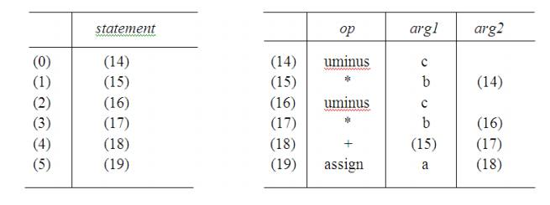
Fig. 3.9 Indirect triples representation of three-address statements

Declarations
As the sequence of declarations in a procedure or block is examined, we can lay out storage for names local to the procedure.

DECLARATIONS
As the sequence of declarations in a procedure or block is examined, we can lay out storage for names local to the procedure. For each local name, we create a symbol-table entry with information like the type and the relative address of the storage for the name. The relative address consists of an offset from the base of the static data area or the field for local data in an activation record.

Declarations in a Procedure:
The syntax of languages such as C, Pascal and Fortran, allows all the declarations in
In the translation scheme shown below:
* Nonterminal P generates a sequence of declarations of the form id : T.
* Before the first declaration is considered, offset is set to 0. As each new name is seen , that name is entered in the symbol table with offset equal to the current value of offset, and offset is incremented by the width of the data object denoted by that name.

* The procedure enter( name, type, offset ) creates a symbol-table entry for name, gives its type type and relative address offset in its data area.

* Attribute type represents a type expression constructed from the basic types integer and real by applying the type constructors pointer and array. If type expressions are represented by graphs, then attribute type might be a pointer to the node representing a type expression.
* The width of an array is obtained by multiplying the width of each element by the
number of elements in the array. The width of each pointer is assumed to be 4.

Computing the types and relative addresses of declared names
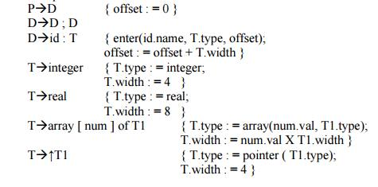
Keeping Track of Scope Information:
When a nested procedure is seen, processing of declarations in the enclosing procedure is temporarily suspended. This approach will be illustrated by adding semantic rules to the following language:
P->D
D->D; D |id: T |proc id; D ; S
One possible implementation of a symbol table is a linked list of entries for names. A new symbol table is created when a procedure declaration D◊ proc id D1;S is seen, and entries for the declarations in D1 are created in the new table. The new table points back to the symbol table of the enclosing procedure; the name represented by id itself is local to the enclosing procedure. The only change from the treatment of variable declarations is that the procedure enter is told which symbol table to make an entry in.

For example, consider the symbol tables for procedures readarray, exchange, and quicksort pointing back to that for the containing procedure sort, consisting of the entire program. Since partition is declared within quicksort, its table points to that of quicksort.

The semantic rules are defined in terms of the following operations:

1. mktable(previous) creates a new symbol table and returns a pointer to the new table. The argument previous points to a previously created symbol table, presumably that for the enclosing procedure.

2. enter(table, name, type, offset) creates a new entry for name name in the symbol table pointed to by table. Again, enter places type type and relative address offset in fields within the entry.

3. addwidth(table, width) records the cumulative width of all the entries in table in the header associated with this symbol table.

4. enterproc(table, name, newtable) creates a new entry for procedure name in the symbol table pointed to by table. The argument newtable points to the symbol table for this procedure name.

Syntax directed translation scheme for nested procedures
P->M D { addwidth ( top( tblptr) , top (offset));
pop (tblptr); pop (offset) }

M->ɛ { t : = mktable (nil);

push (t,tblptr); push (0,offset) }
D->D1 ; D2
D->proc id ; N D1; S { t : = top (tblptr);
addwidth ( t, top (offset));
pop (tblptr); pop (offset);
enterproc (top (tblptr), id.name, t) }

D->id : T { enter (top (tblptr), id.name, T.type, top (offset));
top (offset) := top (offset) + T.width }

N->ɛ { t := mktable (top (tblptr));
push (t, tblptr); push (0,offset) }

* The stack tblptr is used to contain pointers to the tables for sort, quicksort, and partition when the declarations in partition are considered.

* The top element of stack offset is the next available relative address for a local of the current procedure.

are done before actionA at the end of the production occurs. Hence, the action associated with the marker M is the first to be done.

The action for nonterminal M initializes stack tblptr with a outermost scope, created by operation mktable(nil). The action also pushes relative address 0 onto stack offset. Similarly, the nonterminal N uses the operation mktable(top(tblptr)) to create a new symbol table. The argument top(tblptr) gives the enclosing scope for the new table. For each variable declaration id: T, an entry is created for id in the current symbol table.

The top of stack offset is incremented by T.width. When the action on the right side of D -> proc id; ND1; S occurs, declarations generated by D1 is on the top of stack offset; it is recorded using addwidth. Stacks tblptr and offset are then popped. At this point, the name of the enclosed procedure is entered into the symbol table of its enclosing procedure.

Assignment Statements
Suppose that the context in which an assignment appears is given by the following grammar.

ASSIGNMENT STATEMENTS

Suppose that the context in which an assignment appears is given by the following grammar.
P->M D
M->ɛ
D->D ; D | id: T | proc id; N D ; S
N->ɛ

Nonterminal P becomes the new start symbol when these productions are added to those in the tran slation scheme shown below.

Translation scheme to produce three-address code for assignments

S->id : = E { p : = lookup ( id.name); if p ≠ nil then
emit( p ‘ : =’ E.place) else error }
E->E1 + E2 { E.place : = newtemp;
emit( E.place ‘: =’ E1.place ‘ + ‘ E2.place ) }
E->E1 * E2 { E.place : = newtemp;
emit( E.place ‘: =’ E1.place ‘ * ‘ E2.place ) }
E->-E1 { E.place : = newtemp;
emit ( E.place ‘: =’ ‘uminus’ E1.place ) }
E-> ( E1) { E.place : = E1.place }

E->id { p : = lookup ( id.name); if p ≠ nil then
E.place : = p else error }

Reusing Temporary Names

The temporaries used to hold intermediate values in expression calculations tend to clutter up the symbol table, and space has to be allocated to hold their values. Temporaries can be reused by changing newtemp. The code generated by the rules for E ◊ E1 + E2 has the general form:
evaluate E1 into t1
evaluate E2 into t2
t : = t1 + t2

* The lifetimes of these temporaries are nested like matching pairs of balanced parentheses.

* Keep a count c , initialized to zero. Whenever a temporary name is used as an operand, decrement c by 1. Whenever a new temporary name is generated, use $c and increase c by 1.

* For example, consider the assignment x := a * b + c * d - e * f
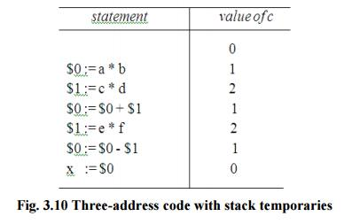

Addressing Array Elements:

Elements of an array can be accessed quickly if the elements are stored in a block of consecutive locations. If the width of each array element is w, then the ith element of array A begins in location

base + ( i - low ) x w

where low is the lower bound on the subscript and base is the relative address of the storage allocated for the array. That is, base is the relative address of A[low].

The expression can be partially evaluated at compile time if it is rewritten
ixw+ (base-low x w)

The subexpression c = base - low x w can be evaluated when the declaration of the array is seen. We assume that c is saved in the symbol table entry for A , so the relative address of A[i] is obtained by simply adding i x w to c.

Address calculation of multi-dimensional arrays:

A two-dimensional array is stored in of the two forms :
Row-major (row-by-row)
Column-major (column-by-column)

In the case of row-major form, the relative address of A[ i1 , i2] can be calculated by the formula base + ((i1 - low1) x n2 + i2 - low2) x w

where, low1 and low2 are the lower bounds on the values of i1 and i2 and n2 is the number of values that i2 can take. That is, if high2 is the upper bound on the value of i2, then n2 = high2 - low2 + 1.

Assuming that i1 and i2 are the only values that are known at compile time, we can rewrite the above expression as
(( i1 x n2 ) + i2 ) x w + ( base - (( low1 x n2 ) + low2 ) x w)
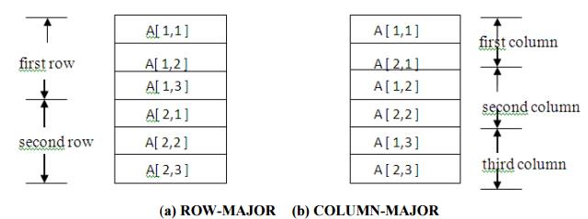
Fig. 3.11 Layouts for a 2 x 3 array

Type conversion within Assignments :

Consider the grammar for assignment statements as above, but suppose there are two types - real and integer , with integers converted to reals when necessary. We have another attribute E.type, whose value is either real or integer. The semantic rule for E.type associated with the production
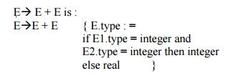
The entire semantic rule for E = E+E ans most o the other productions must modified to generate, when necessary, three-address statements of the form x : = inttoreal y, whose effect is to convert integer y to a real of equal value, called x.
Semantic action for E-> E1+E2
E.place := newtemp;
if E1.type = integer and E2.type = integer then begin
emit( E.place ‘: =’ E1.place ‘int +’ E2.place);
E.type : = integer
end
else if E1.type = real and E2.type = real then begin
emit( E.place ‘: =’ E1.place ‘real +’ E2.place);
E.type : = real
end
else if E1.type = integer and E2.type = real then begin
u : = newtemp;
emit( u ‘: =’ ‘inttoreal’ E1.place);
emit( E.place ‘: =’ u ‘ real +’ E2.place); E.type : = real end
else if E1.type = real and E2.type =integer then begin
u : = newtemp;
emit( u ‘: =’ ‘inttoreal’ E2.place);
emit( E.place ‘: =’ E1.place ‘ real +’ u); E.type : = real end
else
E.type : = type_error;
**************************************************************
For example, for the input x : = y + i * j
assuming x and y have type real, and i and j have type integer, the output would look like
t1 : = i int* j
t3 : = inttoreal t1

t2 : = y real+ t3
x : = t2

Boolean Expressions
Boolean expressions have two primary purposes. They are used to compute logical values, but more often they are used as conditional expressions in statements that alter the flow of control, such as if-then-else, or while-do statements.

BOOLEAN EXPRESSIONS
Boolean expressions have two primary purposes. They are used to compute logical values, but more often they are used as conditional expressions in statements that alter the flow of control, such as if-then-else, or while-do statements.

Boolean expressions are composed of the boolean operators ( and, or, and not ) applied to elements that are boolean variables or relational expressions. Relational expressions are of the form E1 relop E2, where E1 and E2 are arithmetic expressions.
Here we consider boolean expressions generated by the following grammar :
E->EorE | EandE |notE | ( E ) |id relop id | true | false

Methods of Translating Boolean Expressions:
There are two principal methods of representing the value of a boolean expression. They are :

* To encode true and false numerically and to evaluate a boolean expression analogously to an arithmetic expression. Often, 1 is used to denote true and 0 to denote false.

* To implement boolean expressions by flow of control, that is, representing the value of a boolean expression by a position reached in a program. This method is particularly convenient in implementing the boolean expressions in flow-of-control statements, such as the if-then and while-do statements.

Numerical Representation

Here, 1 denotes true and 0 denotes false. Expressions will be evaluated completely from left to right, in a manner similar to arithmetic expressions.
For example :

* The translation for a or b and not c is the three-address sequence
* t1 : = not c
t2 : = b and t1
t3 : = a or t2

* A relational expression such as a < b is equivalent to the conditional statement
* if a < b then 1 else 0

which can be translated into the three-address code sequence (aga statement numbers at 100) :
100 : if a < b goto 103 101 : t : = 0
102 : goto 104
103 : t : = 1
104 :

Translation scheme using a numerical representation for booleans
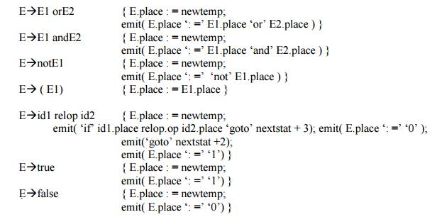

Short-Circuit Code:
We can also translate a boolean expression into three-address code without generating code for any of the boolean operators and without having the code necessarily evaluate the entire expression. This style of evaluation is sometimes called “short-circuit” or “jumping” code. It is possible to evaluate boolean expressions without generating code for the boolean operators and, or, and not if we represent the value of an expression by a position in the code sequence.

Translation of a < b or c < d and e < f
100 : if a < b goto
103 101 : t1 : = 0
102 : goto 104 103 : t1 : = 1

104 : if c < d goto
107 105 : t2 : = 0
106 : goto 108
107 : t2 : = 1
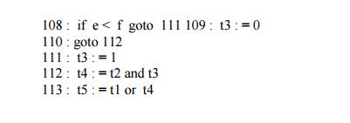
Flow-of-Control Statements
We now consider the translation of boolean expressions into three address code in the context of if-then, if-then-else, and while-do statements such as those generated by the following grammar:
S->ifEthenS1
| if E then S1 else S2
| while E do S1
In each of these productions, E is the Boolean expression to be translated. In the translation, we assume that a three-address statement can be symbolically labeled, and that the function newlabel returns a new symbolic label each time it is called.

* E.true is the label to which control flows if E is true, and E.false is the label to which control flows if E is false.

* The semantic rules for translating a flow-of-control statement S allow control to flow from the translation S.code to the three-address instruction immediately following S.code.

* S.next is a label that is attached to the first three-address instruction to be executed after the code for S.

Case Statements
The “switch” or “case” statement is available in a variety of languages.

CASE STATEMENTS
The “switch” or “case” statement is available in a variety of languages. The switch-statement syntax is as shown below :

Switch-statement syntax s
witch expression
begin

case value : statement
case value : statement
..

case value : statement
default : statement
end

There is a selector expression, which is to be evaluated, followed by n constant values that the expression might take, including a default “value” which always matches the expression if no other value does. The intended translation of a switch is code to:
1. Evaluate the expression.
2. Find which value in the list of cases is the same as the value of the expression.
3. Execute the statement associated with the value found.

Step (2) can be implemented in one of several ways :
By a sequence of conditional goto statements, if the number of cases is small.
* By creating a table of pairs, with each pair consisting of a value and a label for the code

of the corresponding statement. Compiler generates a loop to compare the value of the expression with each value in the table. If no match is found, the default (last) entry is sure to match.

* If the number of cases s large, it is efficient to construct a hash table.

* There is a common special case in which an efficient implementation of the n-way branch exists. If the values all lie in some small range, say imin to imax, and the number of different values is a reasonable fraction of imax - imin, then we can construct an array of labels, with the label of the statement for value j in the entry of the table with offset j - imin and the label for the default in entries not filled otherwise. To perform switch, evaluate the expression to obtain the value of j , check the va transfer to the table entry at offset j-imin .

Syntax-Directed Translation of Case Statements:

Consider the following switch statement:
switch E
begin

case V1 : S1 case V2 : S2

case Vn-1 : Sn-1
default : Sn
end

This case statement is translated into intermediate code that has the following form : Translation of a case statement

code to evaluate E into t goto test

L1 : code for S1 goto next

L2 : code for S2 goto next

Ln-1 : code for Sn-1 goto next

Ln : code for Sn goto next

test : if t = V1 goto L1 if t = V2 goto L2

if t = Vn-1 goto Ln-1 goto Ln
next :
To translate into above form :

* When keyword switch is seen, two new labels test and next, and a new temporary t are generated.
As expression E is parsed, the code to evaluate E into t is generated. After processing E , the jump goto test is generated.

* As each case keyword occurs, a new label Li is created and entered into the symbol table. A pointer to this symbol-table entry and the value Vi of case constant are placed on a stack (used only to store cases).

* Each statement case Vi : Si is processed by emitting the newly c
by the code for Si , followed by the jump goto next.

* Then when the keyword end terminating the body of the switch is found, the code can be generated for the n-way branch. Reading the pointer-value pairs on the case stack from the bottom to the top, we can generate a sequence of three-address statements of the form
case V1 |  | L1
case V2 |  | L2
case | Vn-1 Ln-1
case | t Ln
label next

where t is the name holding the value of the selector expression E, and Ln is the label for the default statement.

Issues in the design of a code generator
The final phase in compiler model is the code generator. It takes as input an intermediate representation of the source program and produces as output an equivalent target program.

CODE GENERATION

The final phase in compiler model is the code generator. It takes as input an intermediate representation of the source program and produces as output an equivalent target program. The code generation techniques presented below can be used whether or not an optimizing phase occurs before code generation.
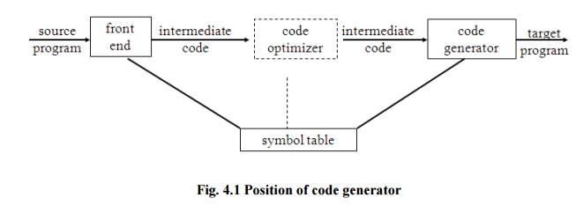

ISSUES IN THE DESIGN OF A CODE GENERATOR
The following issues arise during the code generation phase:
1. Input to code generator
2. Target program
3. Memory management
4. Instruction selection
5. Register allocation
6. Evaluation order

1. Input to code generator:
• The input to the code generation consists of the intermediate representation of the source program produced by front end , together with information in the symbol table to determine run-time addresses of the data objects denoted by the names in the intermediate representation.

• Intermediate representation can be :
a. Linear representation such as postfix notation
b. Three address representation such as quadruples
c. Virtual machine representation such as stack machine code
d. Graphical representations such as syntax trees and dags.
e. • Prior to code generation, the front end must be scanned, parsed and translated into intermediate representation along with necessary type checking. Therefore, input to code generation is assumed to be error-free.
f. 2. Target program:
• The output of the code generator is the target program. The output may be : a. Absolute machine language

- It can be placed in a fixed memory location and can be executed immediately. b. Relocatable machine language
- It allows subprograms to be compiled separately.
c. Assembly language
- Code generation is made easier.

3. Memory management:
• Names in the source program are mapped to addresses of data objects in run-time memory by the front end and code generator.

• It makes use of symbol table, that is, a name in a three-address statement refers to a symbol-table entry for the name.
• Labels in three-address statements have to be converted to addresses of instructions. For example,

j:goto I generates jump instruction as follows:

* if i < j, a backward jump instruction with target address equal to location of code for quadruple i is generated.

* if i > j, the jump is forward. We must store on a list for quadruple i the location of the first machine instruction generated for quadruple j. When i is processed, the machine locations for all instructions that forward jumps to i are filled.

4. Instruction selection:
• The instructions of target machine should be complete and uniform.
• Instruction speeds and machine idioms are important factors when efficiency of target program
is considered.
• The quality of the generated code is determined by its speed and size.
• The former statement can be translated into the latter statement as shown below:

a:=b+c
d:=a+e (a)
MOV b,R0
ADD c,R0
MOV R0,a (b)
MOV a,R0
ADD e,R0
MOV R0,d

5. Register allocation
• Instructions involving register operands are shorter and faster than those involving operands in memory. The use of registers is subdivided into two subproblems :

1. Register allocation - the set of variables that will reside in registers at a point in the program is selected.
2. Register assignment - the specific register that a value picked•
3. Certain machine requires even-odd register pairs for some operands and results. For example , consider the division instruction of the form :D x, y

where, x - dividend even register in even/odd register pair y-divisor
even register holds the remainder
odd register holds the quotient

6. Evaluation order
• The order in which the computations are performed can affect the efficiency of the target code.

Some computation orders require fewer registers to hold intermediate results than others.

TARGET MACHINE
• Familiarity with the target machine and its instruction set is a prerequisite for designing a good code generator.
• The target computer is a byte-addressable machine with 4 bytes to a word.
• It has ngeneral-purpose registers, R₀, R₁, . . . , R_{n-1}.
• It has two-address instructions of the form:
o op source, destination
o where, op is an op-code, and source and destination are data fields.

· It has the following op-codes :
o MOV (move sourcetodstination)
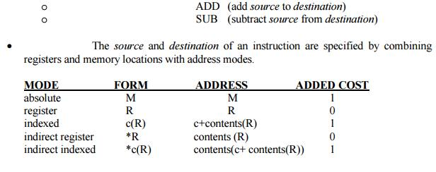

For example : MOV R₀, M stores contents of Register R₀ into memory location M.

Instruction costs :

• Instruction cost = 1+cost for source and destination address modes. This cost corresponds to the length of the instruction.
• Address modes involving registers have cost zero.

• Address modes involving memory location or literal have cost one.

• Instruction length should be minimized if space is important. Doing so also minimizes the time taken to fetch and perform the instruction.

For example : MOV R0, R1 copies the contents of register R0 into R1. It has cost one, since

occupies only one word of memory.
• The three-address statement a : = b + c can be implemented by many different instruction sequences :

- MOV b, R0
ADD c, R0 cost = 6 MOV R0, a
ii) MOV b, a
ADD c, a cost = 6
iii) Assuming R0, R1 and R2 contain the addresses of a, b, and c : MOV *R1, *R0
ADD *R2, *R0 cost = 2

• In order to generate good code for target machine, we must utilize its addressing capabilities efficiently.

A Simple Code Generator
If the name in a register is no longer needed, then we remove the name from the register and the register can be used to store some other names.

NEXT-USE INFORMATION

• If the name in a register is no longer needed, then we remove the name from the register and the register can be used to store some other names.

Input: Basic block B of three-address statements
Output: At each statement i: x= y op z, we attach to i the liveliness and next-uses of x, y and z.

Method: We start at the last statement of B and scan backwards.
1. Attach to statement i the information currently found in the symbol table regarding the next-use and liveliness of x, y and z.

2. In the symbol table, set x to “not live” and “no next use”.
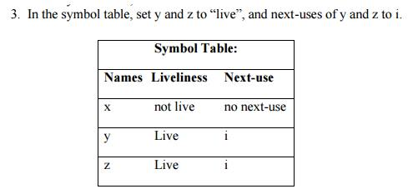
A SIMPLE CODE GENERATOR
• A code generator generates target code for a sequence of three- address statements and
effectively uses registers to store operands of the statements.
• For example: consider the three-address statement a := b+c It can have the following sequence of codes:

ADD Rj, Ri Cost = 1
(or)
ADD c, Ri Cost = 2
(or)
MOV c, Rj Cost = 3
ADD Rj, Ri

Register and Address Descriptors:
• A register descriptor is used to keep track of what is currently in each registers. The register
descriptors show that initially all the registers are empty.
• An address descriptor stores the location where the current value of the name can be found at run time.

A code-generation algorithm:

The algorithm takes as input a sequence of three-address statements constituting a basic block. For each three-address statement of the form x : = y op z, perform the following actions:

1. Invoke a function getreg to determine the location L where the result of the computation y op z should be stored.

2. Consult the address descriptor for y to determine y’, the current location of y. Prefer the register for y’ if the value of y is currently both in memory and a register. If the value of y is not already in L, generate the instruction MOV y’ , L to place a copy of y in L.

3. Generate the instruction OP z’ , L where z’ is a current location of z. Prefer a register to a memory location if z is in both. Update the address descriptor of x to indicate that x is in location L. If x is in L, update its descriptor and remove x from all other descriptors.

4. If the current values of y or z have no next uses, are not live on exit from the block, and are in registers, alter the register descriptor to indicate that, after execution of x : = y op z , those registers will no longer contain y or z

Generating Code for Assignment Statements:

• The assignment d : = (a-b) + (a-c) + (a-c) might be translated into the following three-address code sequence:
Code sequence for the example is:
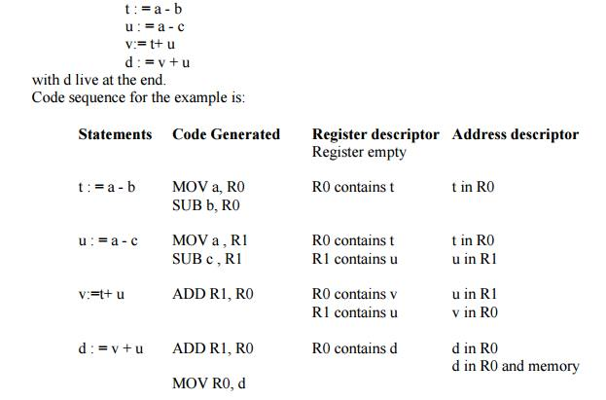

Generating Code for Indexed Assignments
The table shows the code sequences generated for the indexed assignmen a:= b[ i ] and a[ i ]:= b
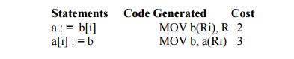

Generating Code for Pointer Assignments
The table shows the code sequences generated for the pointer assignments a : = *p and *p : = a

if x < 0 goto z ADD z, R0
MOV R0,x
CJ< z

Generating Code From DAGs
The advantage of generating code for a basic block from its dag representation is that from a dag we can easily see how to rearrange the order of the final computation sequence than we can start from a linear sequence of three-address statements or quadruples.

GENERATING CODE FROM DAGs

The advantage of generating code for a basic block from its dag representation is that from a dag we can easily see how to rearrange the order of the final computation sequence than we can start from a linear sequence of three-address statements or quadruples.

Rearranging the order

The order in which computations are done can affect the cost of resulting object code. For example, consider the following basic block:
t1 : = a + b
t2 : = c + d
t3 : = e - t2
t4 : = t1 - t3

Generated code sequence for basic block:
MOV a , R0
ADD b , R0
MOV c , R1
ADD d , R1
MOV R0 , t1
MOV e , R0
SUB R1 , R0
MOV t1 , R1
SUB R0 , R1
MOV R1 , t4

Rearranged basic block:
Now t1 occurs immediately before t4.
t2 : = c + d
t3 : = e - t2
t1 : = a + b
t4 : = t1 - t3
Revised code sequence:
MOV c , R0
ADD d , R0
MOV a , R0
SUB R0 , R1
MOV a , R0
ADD b , R0
SUB R1 , R0
MOV R0 , t4
In this order, two instructions MOV R0 , t1 and MOV t1 , R1 have been saved.

A Heuristic ordering for Dags

The heuristic ordering algorithm attempts to make the evaluation of a nod the evaluation of its leftmost argument. The algorithm shown below produces the ordering in reverse.

Algorithm:
1) while unlisted interior nodes remain do begin
2) select an unlisted node n, all of whose parents have been listed;
3) list n;
4) while the leftmost child m of n has no unlisted parents and is not a leaf do
begin
5) list m;
6) n : = m

end
end

Example: Consider the DAG shown below
Initially, the only node with no unlisted parents is 1 so set n=1 at line (2) and list 1 at line (3). Now, the left argument of 1, which is 2, has its parents listed, so we list 2 and set n=2 at line (6). Now, at line (4) we find the leftmost child of 2, which is 6, has an unlisted parent 5. Thus we select a new n at line (2), and node 3 is the only candidate. We list 3 and proceed down its left chain, listing 4, 5 and 6. This leaves only 8 among the interior nodes so we list that. The resulting list is 1234568 and the order of evaluation is 8654321.

Code sequence:
t8 : = d + e
t6 : = a + b
t5 : = t6 - c
t4 : = t5 * t8
t3 : = t4 - e
t2 : = t6 + t4
t1 : = t2 * t3
This will yield an optimal code for the DAG on machine whatever be the number of registers.

Fig. 4.7 A DAG

Run-Time Storage Management
Information needed during an execution of a procedure is kept in a block of storage called an activation record, which includes storage for names local to the procedure.

RUN-TIME STORAGE MANAGEMENT

• Information needed during an execution of a procedure is kept in a block of storage called an activation record, which includes storage for names local to the procedure. The two standard storage allocation strategies are:
1. Static allocation 2. Stack allocation

• In static allocation, the position of an activation record in memory is fixed at compile time.
• In stack allocation, a new activation record is pushed onto the stack for each execution of a

procedure. The record is popped when the activation ends.

• The following three-address statements are associated with the run-time allocation and deallocation of activation records:
1. Call,
2. Return,
3. Halt, and
4. Action, a placeholder for other statements.

• We assume that the run-time memory is divided into areas for:

1. Code
2. Static data
3. Stack

Static allocation
Implementation of call statement:
The codes needed to implement static allocation are as follows:
MOV #here + 20, callee.static_area /*It saves return address*/

GOTO callee.code_area /*It transfers control to the target code for the called
procedure */
where,
callee.static_area - Address of the activation record
callee.code_area - Address of the first instruction for called procedure
#here + 20 - Literal return address which is the address of the instruction following GOTO.

Implementation of return statement:
A return from procedure callee is implemented by : GOTO *callee.static_area
This transfers control to the address saved at the beginning of the activation record.

Implementation of action statement:
The instruction ACTION is used to implement action statement.

Implementation of halt statement:
The statement HALT is the final instruction that returns control to the operating system.

Stack allocation

Static allocation can become stack allocation by using relative addresses for storage in activation records. In stack allocation, the position of activation record is stored in register so words in activation records can be accessed as offsets from the value in this register.

The codes needed to implement stack allocation are as follows:

Initialization of stack:
MOV #stackstart , SP /* initializes stack */
Code for the first procedure
HALT /* terminate execution */

Error Handling in Compiler Design
The tasks of the Error Handling process are to detect each error, report it to the user, and then make some recover strategy and implement them to handle error. During this whole process processing time of program should not be slow. An Error is the blank entries in the symbol table.
Types or Sources of Error – There are two types of error: run-time and compile-time error:
- A run-time error is an error which takes place during the execution of a program, and usually happens because of adverse system parameters or invalid input data. The lack of sufficient memory to run an application or a memory conflict with another program and logical error are example of this. Logic errors, occur when executed code does not produce the expected result. Logic errors are best handled by meticulous program debugging.
- Compile-time errors rises at compile time, before execution of the program. Syntax error or missing file reference that prevents the program from successfully compiling is the example of this.
Classification of Compile-time error –
- Lexical : This includes misspellings of identifiers, keywords or operators
- Syntactical : missing semicolon or unbalanced parenthesis
- Semantical : incompatible value assignment or type mismatches between operator and operand
- Logical : code not reachable, infinite loop.
Finding error or reporting an error – Viable-prefix is the property of a parser which allows early detection of syntax errors.
- Goal: detection of an error as soon as possible without further consuming unnecessary input
- How: detect an error as soon as the prefix of the input does not match a prefix of any string in the
language.
- Example: for(;), this will report an error as for have two semicolons inside braces.
Error Recovery –
The basic requirement for the compiler is to simply stop and issue a message, and cease compilation. There are some common recovery methods that are follows.
- Panic mode recovery: This is the easiest way of error-recovery and also, it prevents the parser from developing infinite loops while recovering error. The parser discards the input symbol one at a time until one of the designated (like end, semicolon) set of synchronizing tokens (are typically the statement or expression terminators) is found. This is adequate when the presence of multiple errors in same statement is rare. Example: Consider the erroneous expression- (1 + + 2) + 3. Panic-mode recovery: Skip ahead to next integer and then continue. Bison: use the special terminal error to describe how much input to skip.
E->int|E+E|(E)|error int|(error)
- Phase level recovery: Perform local correction on the input to repair the error. But error correction is difficult in this strategy.
- Error productions: Some common errors are known to the compiler designers that may occur in the code. Augmented grammars can also be used, as productions that generate erroneous constructs when these errors are encountered. Example: write 5x instead of 5*x
- Global correction: Its aim is to make as few changes as possible while converting an incorrect input string to a valid string. This strategy is costly to implement.

Error detection and Recovery in Compiler
In this phase of compilation, all possible errors made by the user are detected and reported to the user in form of error messages. This process of locating errors and reporting it to user is called Error Handling process.
Functions of Error handler
- Detection
- Reporting
- Recovery

Classification of Errors

Compile time errors are of three types:-
  - Lexical phase errors
These errors are detected during the lexical analysis phase. Typical lexical errors are
- Exceeding length of identifier or numeric constants.
- Appearance of illegal characters
- Unmatched string
Example 1 : printf("Geeksforgeeks");$
This is a lexical error since an illegal character $ appears at the end of statement.

Example 2 : This is a comment */
This is an lexical error since end of comment is present but beginning is not present.
Error recovery:
Panic Mode Recovery
- In this method, successive characters from the input are removed one at a time until a designated set of synchronizing tokens is found. Synchronizing tokens are delimiters such as; or }
- Advantage is that it is easy to implement and guarantees not to go to infinite loop
- Disadvantage is that a considerable amount of input is skipped without checking it for additional errors
  - Syntactic phase errors
These errors are detected during syntax analysis phase. Typical syntax errors are
- Errors in structure
- Missing operator
- Misspelled keywords
- Unbalanced parenthesis
Example : swicth(ch)
{
.......
.......
}
The keyword switch is incorrectly written as swicth. Hence, “Unidentified keyword/identifier” error occurs.
Error recovery:
- Panic Mode Recovery
  - In this method, successive characters from input are removed one at a time until a designated set of synchronizing tokens is found. Synchronizing tokens are deli-meters such as ; or }
  - Advantage is that its easy to implement and guarantees not to go to infinite loop
  - Disadvantage is that a considerable amount of input is skipped without checking it for additional errors
- Statement Mode recovery
  - In this method, when a parser encounters an error, it performs necessary correction on remaining input so that the rest of input statement allow the parser to parse ahead.
  - The correction can be deletion of extra semicolons, replacing comma by semicolon or inserting missing semicolon.
  - While performing correction, atmost care should be taken for not going in infinite loop.
  - Disadvantage is that it finds difficult to handle situations where actual error occured before point of detection.
- Error production
  - If user has knowledge of common errors that can be encountered then, these errors can be incorporated by augmenting the grammar with error productions that generate erroneous constructs.
  - If this is used then, during parsing appropriate error messages can be generated and parsing can be continued.
  - Disadvantage is that its difficult to maintain.
- Global Correction
  - The parser examines the whole program and tries to find out the closest match for it which is error free.
  - The closest match program has less number of insertions, deletions and changes of tokens to recover from erroneous input.
  - Due to high time and space complexity, this method is not implemented practically.

  - Semantic errors
These errors are detected during semantic analysis phase. Typical semantic errors are
- Incompatible type of operands
- Undeclared variables
- Not matching of actual arguments with formal one
Example : int a[10], b;
.......
.......
a = b;
It generates a semantic error because of an incompatible type of a and b.
Error recovery
- If error “Undeclared Identifier” is encountered then, to recover from this a symbol table entry for corresponding identifier is made.
- If data types of two operands are incompatible then, automatic type conversion is done by the compiler.

Type Checking
A compiler must check that the source program follows both syntactic and semantic conventions of the source language. This checking, called static checking, detects and reports programming errors.

TYPE CHECKING

A compiler must check that the source program follows both syntactic and semantic conventions of the source language. This checking, called static checking, detects and reports programming errors.
Some examples of static checks:
1. Type checks - A compiler should report an error if an operator is applied to an incompatible operand. Example: If an array variable and function variable are added together.
2. Flow-of-control checks - Statements that cause flow of control to leave a construct must have some place to which to transfer the flow of control. Example: An enclosing statement, such as break, does not exist in switch statement.
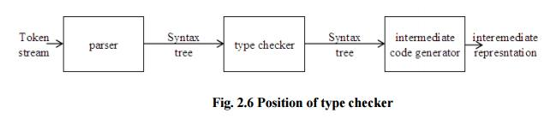
A typechecker verifies that the type of a construct matches that expected by its context. For example : arithmetic operator mod in Pascal requires integer operands, so a type checker verifies that the operands of mod have type integer. Type information gathered by a type checker may be needed when code is generated.

Type Systems

The design of a type checker for a language is based on information about the syntactic constructs in the language, the notion of types, and the rules for assigning types to language
constructs.
For example : “ if both operands of the arithmetic operators of +,- and * are of type integer, then the result is of type integer ”

Type Expressions
The type of a language construct will be denoted by a “type expression.” A type expression is either a basic type or is formed by applying an operator called a type constructor to other type expressions. The sets of basic types and constructors depend on the language to be checked. The following are the definitions of type expressions:
1. Basic types such as boolean, char, integer, real are type expressions.
A special basic type, type_error , will signal an error during type checking; void denoting “the absence of a value” allows statements to be checked.

2. Since type expressions may be named, a type name is a type expression.
3. A type constructor applied to type expressions is a type expression.

Constructors include:

Arrays : If T is a type expression then array (I,T) is a type expression denoting the type of an array with elements of type T and index set I.

Products : If T1 and T2 are type expressions, then their Cartesian product T1 X T2 is a type expression.

Records : The difference between a record and a product is that the names. The record type constructor will be applied to a tuple formed from field names and field types.

For example:

type row = record
address: integer;
lexeme: array[1..15] of char
end;
var table: array[1...101] of row;

declares the type name row representing the type expression record((address X integer) X (lexeme X array(1..15,char))) and the variable table to be an array of records of this type.

Pointers : If T is a type expression, then pointer(T) is a type expression denoting the type “pointer to an object of type T”.
For example, var p: ↑ row declares variable p to have type pointer(row).
Functions : A function in programming languages maps a domain type D to a range type R. The type of such function is denoted by the type expression D → R
4. Type expressions may contain variables whose values are type expressions.
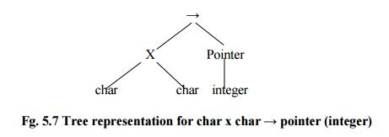

Type systems

A type system is a collection of rules for assigning type expressions to the various parts of a program. A type checker implements a type system. It is specified in a syntax-directed manner. Different type systems may be used by different compilers or processors of the same language.

Static and Dynamic Checking of Types

Checking done by a compiler is said to be static, while checking done when the target program runs is termed dynamic. Any check can be done dynamically, if the target code carries the type of an element along with the value of that element.

Sound type system

A sound type system eliminates the need for dynamic checking.It allows us to determine statically that these errors cannot occur when the target program runs. That is, if a sound type system assigns a type other than type_error to a program part, then type errors cannot occur when the target code for the program part is run.

Strongly typed language

A language is strongly typed if its compiler can guarantee that the programs it accepts will execute without type errors.

